
Topic unit:

Big question: How do Muslims show commitment to God (Allah)?
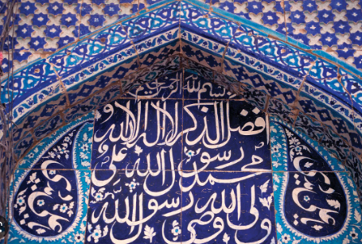

Faith: Islam
What I need to know and remember by the end of the unit:
•Understand what commitment means in Islam.
•There are five pillars in Islam – Religious duties that are required of every Muslim
The Shahadah – Call to faith, Salat – The role of prayer in a Muslim’s life, Sawm – Call to fasting, Zakat – Giving to charity, Hajj – The importance of pilgrimage.
•To understand how a Muslim shows commitment to God (Allah) and draws closer to him through the five pillars.

Week 1: What does it mean to make a commitment? How might a Muslim show their commitment to their faith?
Week 2: How does a Muslim show their commitment to God (Allah) through prayer and confession of faith?
Week 3: How does giving to charity show a commitment to God (Allah)?
Week 4: How does fasting show commitment to God (Allah)?
Week 5: How does pilgrimage show a commitment to God (Allah)?
Week 6: How do Muslims show commitment to God (Allah)?

Key Vocabulary

Islam | An Arabic word meaning "submission" and in the religious context it means "submission to the will of God". Islam is derived from the Arabic word ‘sal'm’ which literally means peace.
Allah | Arabic word for God.
Quran | Qur’an: Holy book for Muslims
The five pillars of Islam: | The Shahadah, Salat, Sawm, Zakat, Hajj.
Makkah | City where the Prophet Muhammad (pbuh) was born, and where the Ka’bah is located.
Commitment: | Dedicating yourself to someone or something.

