

Topic unit:
How do the symbols of Easter help us to understand the meaning of Easter for Christianity?

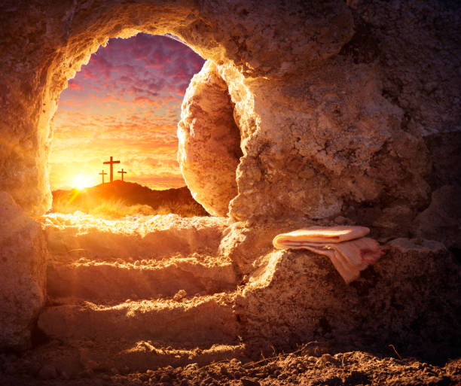
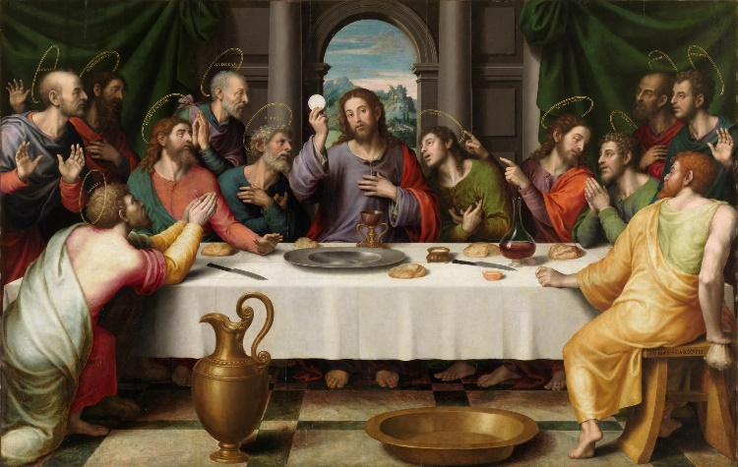
Faith: Christianity
Key Vocabulary

Salvation | To be rescued/saved by God. Relationship between God and humankind is restored.
Symbol | An iconic representation of a specific religion or religious concept.
Last Supper | The last meal Jesus ate with his disciples.
Holy Communion | A service that recalls the last meal of Jesus and celebrates his sacrificial and saving death. It is the coming together as the Body of Christ.
Passover/Pesach: | Festival commemorating the Exodus (leaving) from Egypt.
Sacrifice | A divine offering. Christ gave up his life for humanity. He was the ultimate sacrifice.

Weekly Questions:
Week 1: How do different symbols help us to remember the story of Easter?

Week 2: What do the symbols of bread and wine teach us about the meaning of Easter for Christians?

Week 3 & 4: What does the symbol of the cross teach us about the meaning of Easter for Christians?

What I need to know and remember by the end of the unit:

- To know and remember the meaning of Salvation
- To know & retell the Easter story
- To know and remember which symbols teach us about the meaning of Easter for Christians: bread/wine/cross

