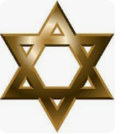
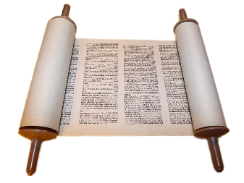
Why are they having a party?
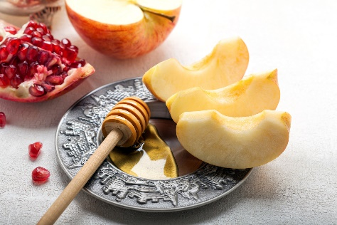
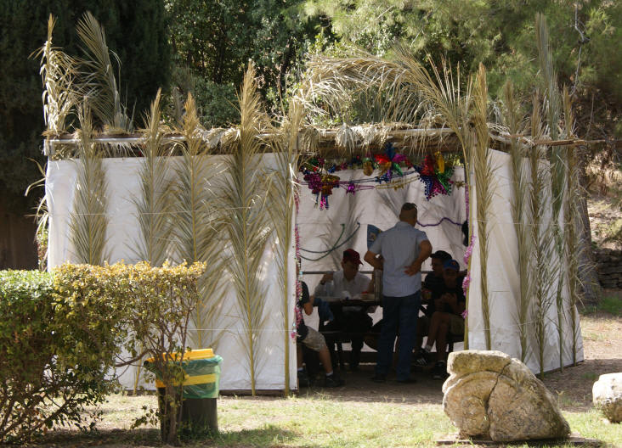
Judaism
Key Vocabulary

Festival | A day of celebration
Remembering | Having an awareness of the past
Rosh Hashanah | Jewish New Year festival and commemorates the creation of the world
Yom Kippur | the most sacred and solemn day of the Jewish year, brings the Days of Repentance to a close.
Sukkot | The seven-day festival / celebration of the harvest
Sukkah | A temporary hut constructed for use during the week-long Jewish
Hanukkiah | A candelabrum which has nine branches that is lit during the festival of Hanukkah.

What I need to know and remember by the end of the unit:

- To know some of the key festivals that are important to Jewish people: Rosh Hashanah, Sukkot, Hanukkah)
- To know how each festival is celebrated and its meaning.
- To know that the festivals are key points for the Jewish people in helping them remember their history.

Weekly Questions:
Week 1: Why are they having a party?
Week 2: What is Rosh Hashanah?
Week 3: What is Yom Kippur?
Week 4: Why are they having another Jewish party? (Sukkot)
Week 5: What are the Jewish people remembering at the festival of Sukkot?
Week 6: What are the Jewish people celebrating at their festival of Hanukkah?

