Topic unit:
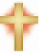
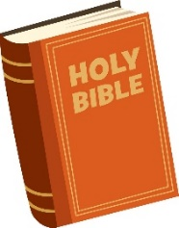
How does the symbol of light help us to understand the meaning of Christmas for Christians?
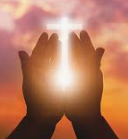
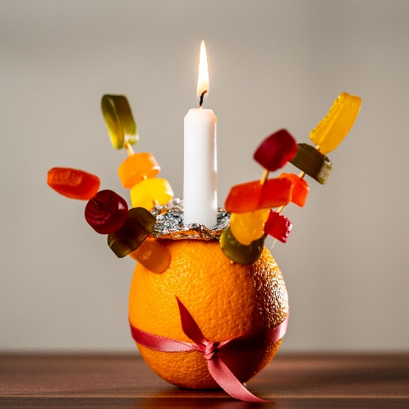
Faith: Christianity
What I need to know and remember by the end of the unit:

• To know and remember the meaning of the core concept: Incarnation.
• To understand why Jesus referred to himself as the light of the world.
• To know and remember the meaning of the symbols in the Christingle.
• To know and remember the key religious vocabulary and what each word means.
Biblical references: Genesis 1 v 26 - 31

Weekly Questions:
Week 1: What does Jesus mean when He says “I am the light of the world”?
Week 2: What do you think the most important symbol on the Christingle is and why?
Week 3: How and why do artists use the symbol of light in their religious paintings?
Week 4: Who is your guiding light?

Key Vocabulary

Incarnation: | The incarnation is the belief that Jesus Christ, the second person of the Trinity, also known as God the Son
Christmas: | Christian Festival that marks the birth of Jesus Christ
Christingle | The red ribbon (or tape) symbolises the love and blood of Christ. The sweets and dried fruit represent all of God's creations. The lit candle represents Jesus's light in the world, bringing hope to people living in darkness.
Light of the world | Jesus said: I am the light of the world. Whoever follows me will never walk in darkness, but will have the light of life. – Bringing hope
Halo | A circle of light shown around or above the head of a holy person or saint to represent their holiness.
Holy | To be set apart, belonging to or devoted to God.

