English Term | Definition
Suffix | a group of letters at the end of a word that change its meaning
Prefix | a group of letters at the beginning of a word that change its meaning
Plural | more than one
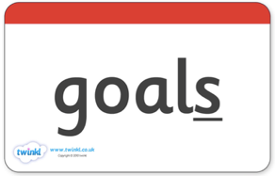
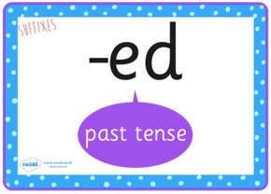
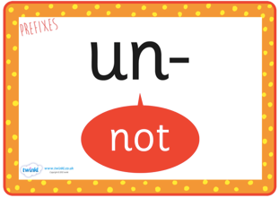
English Term | Definition
  full stop | marks the end of a sentence
  question mark | marks the end of a question
  exclamation mark | marks the end of an exclamation like a shout or a command
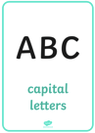  Capital letter | used at the beginning of a sentence and for a name

English Term | Definition
Noun | A person place or thing  Eg. apple
Adjective | A word that describes a noun  Eg. beautiful
Verb | A doing word  Eg. run
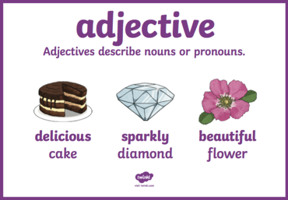
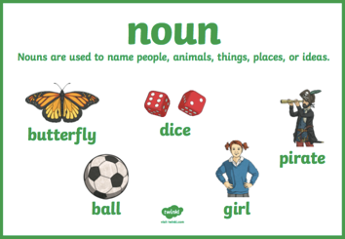
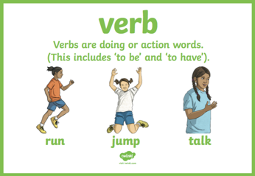
English Term | Definition
Vowel | a e i o u
Consonant | b c d f g h j k l m n p q r s t v w x y z

