Flying High

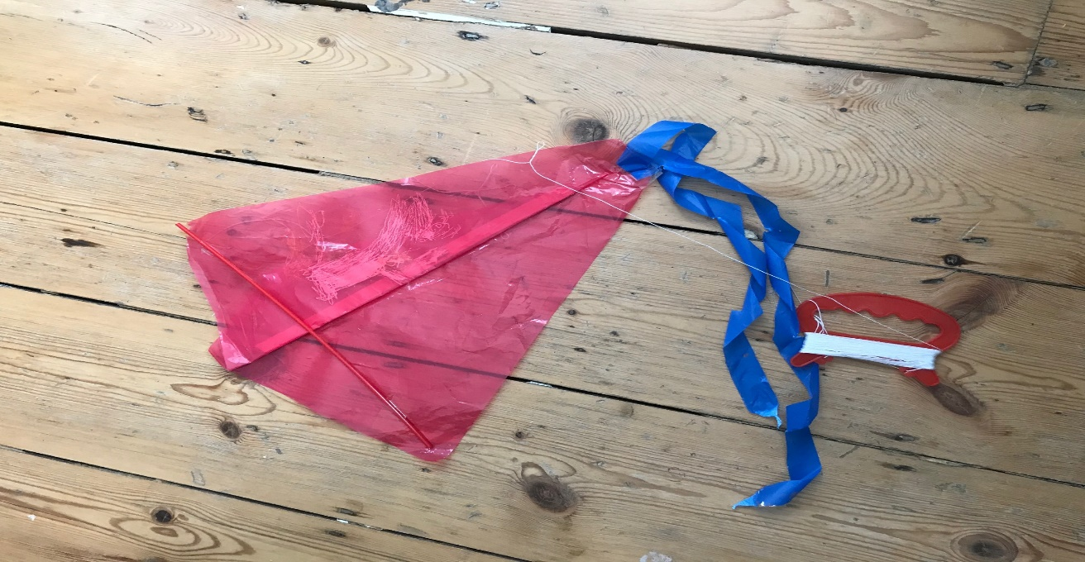
I made a kite from plastic and string.
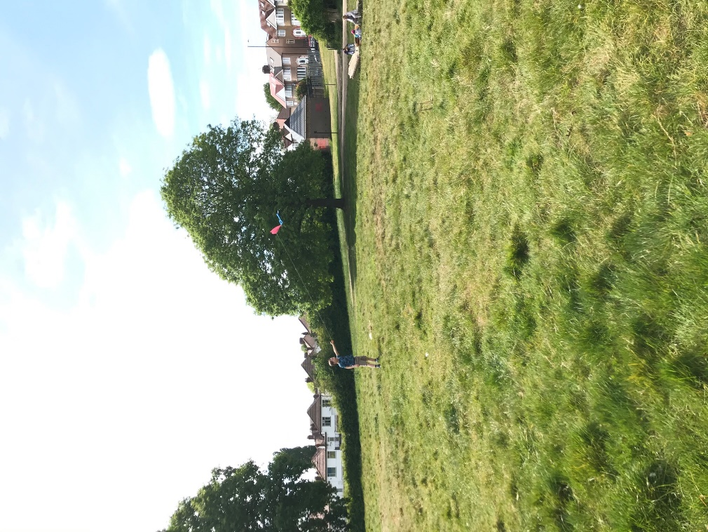
I took it to the park with my mummy, daddy and my brother Arthur. It took a long time to find a quiet place. When we got to the park we went up a hill because it is more windy high up. I ran very fast to get the kite in the air. I had fun flying my kite.

Harry Conway-Williams

