Wales

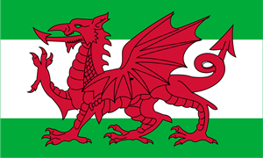

Did You Know?????????????

The country of Wales is part of the United Kingdom along with England, Scotland and Northern Ireland.
Wales is a country famous for its hills, mountains and damp climate.
Wales has its own language and its capital city is Cardiff. The welsh language (Cymraeg) is the oldest language in Britain.
The Welsh national game is rugby.
Wales is surrounded by the sea on three sides.
There are lots of lambs and sheep in Wales.
In the past wales was very famous for its coal mining industry.



