A Dad is Born

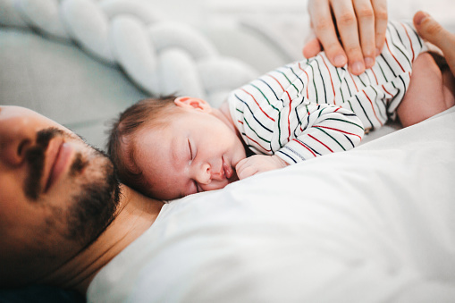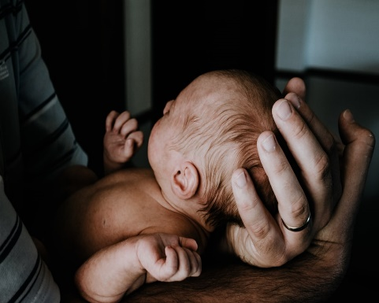
Are you a new dad or about to become a new dad?

Do you have lots of questions or would just like to chat with dads in the same situation?

We have a new zoom group for new dads Wednesday 7:30 – 8:30
Babies welcome

If you are interested email me at Curious.dads1@gmail.com
or
Message me on 07385 398260
Peter Firkin

